Radians
# Source: AI Source: Provided by: [Data Path: Persons Table -> ID Column: 1, Name_En Column: Motasem Essam] -> From: [ChatGPT] on [7/25/2026]
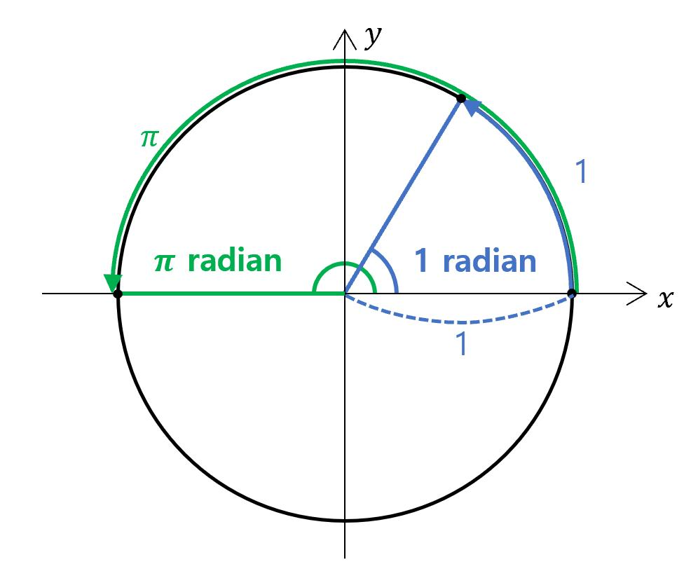
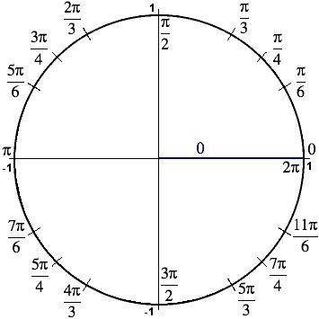
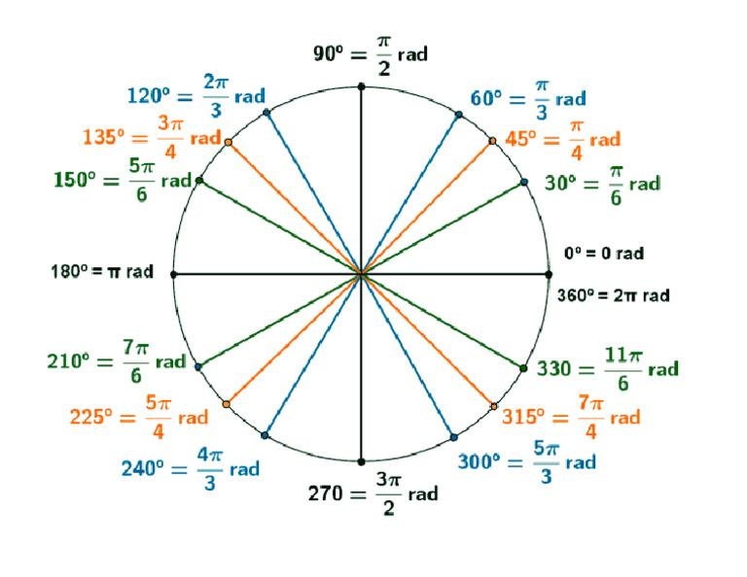
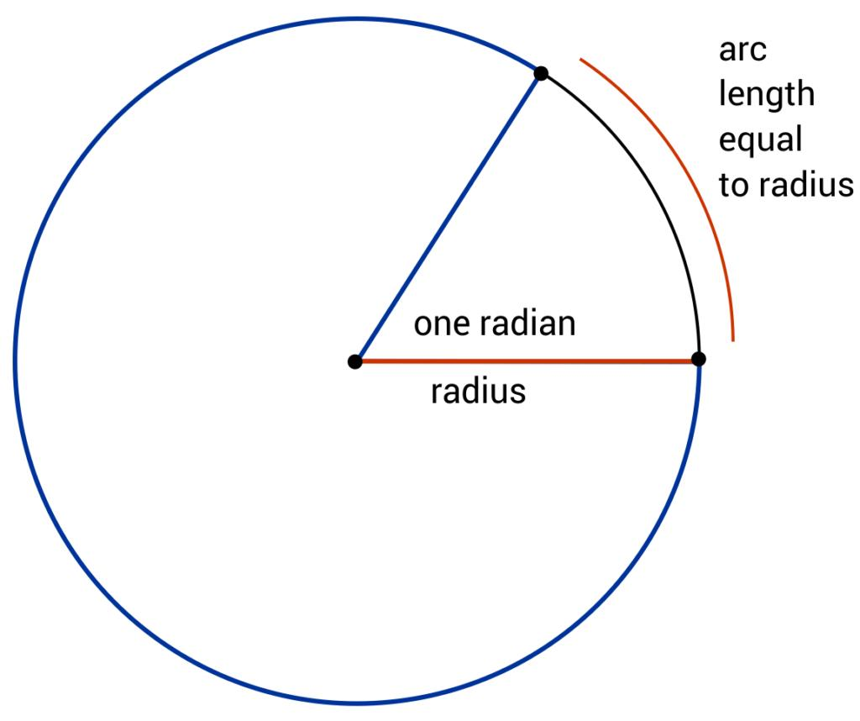
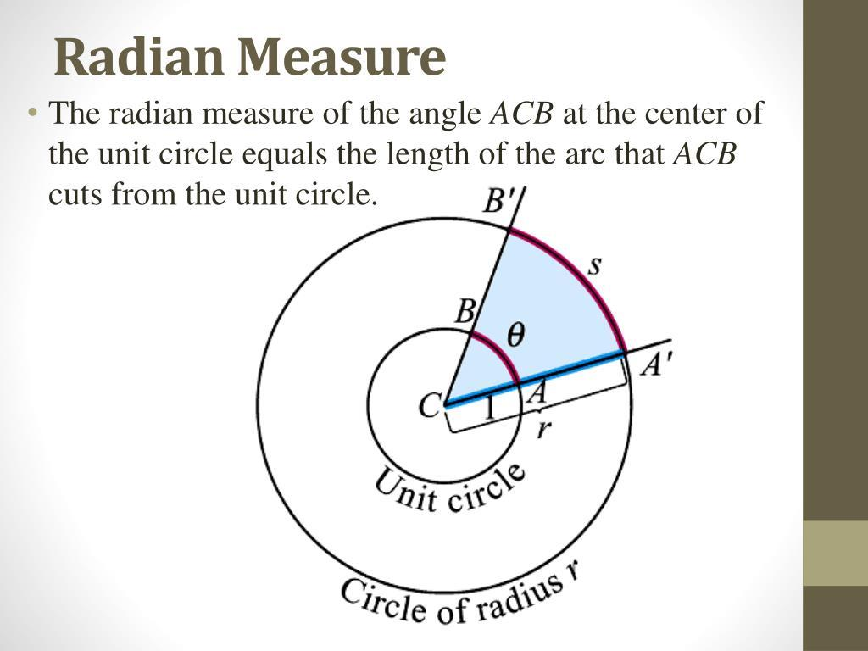
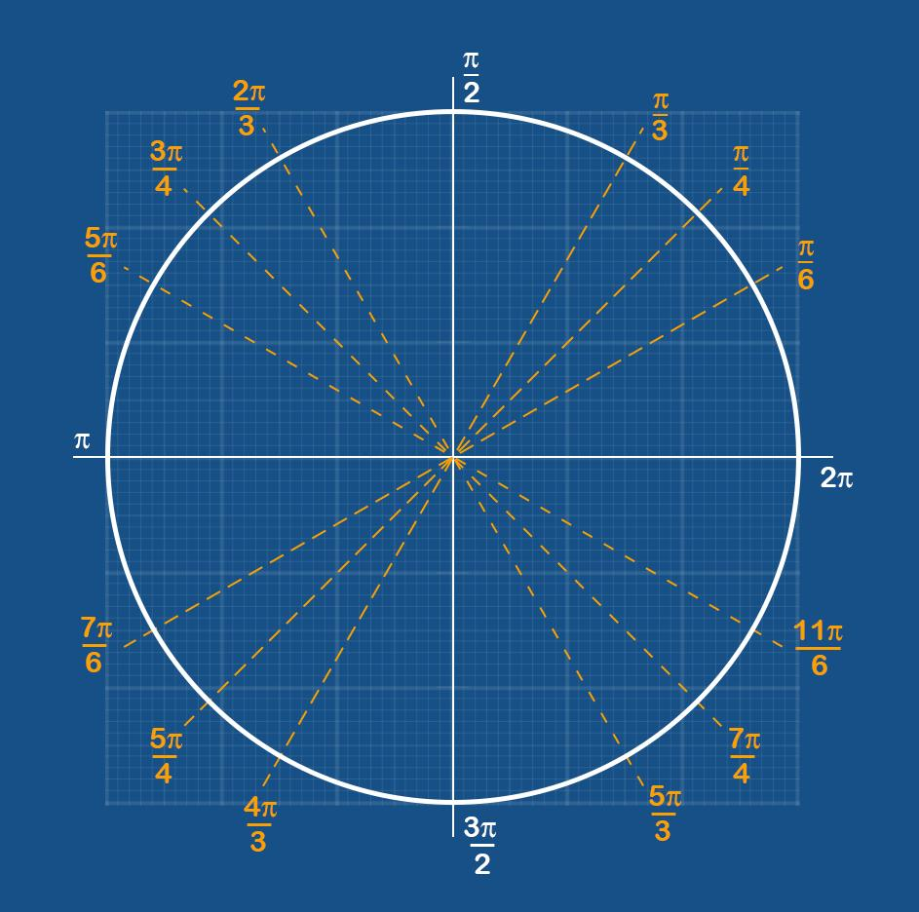

Definition
# Source: AI Source: Provided by: [Data Path: Persons Table -> ID Column: 1, Name_En Column: Motasem Essam] -> From: [ChatGPT] on [7/25/2026]
A Radian is the standard unit of angle measurement in mathematics, especially in trigonometry, calculus, physics, and engineering.
One radian is defined as the angle subtended at the center of a circle by an arc whose length is equal to the radius of the circle.
Unlike degrees, radians are based directly on the geometry of a circle rather than an arbitrary division into 360 parts.

Illustration
# Source: AI Source: Provided by: [Data Path: Persons Table -> ID Column: 1, Name_En Column: Motasem Essam] -> From: [ChatGPT] on [7/25/2026]
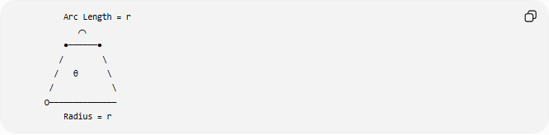
Arc Length = r
⌒
●──────●
/ \
/ θ \
/ \
O──────────────
Radius = r
If:
- Arc length = Radius
then:
$$θ=1\text{ radian}$$

Mathematical Definition
# Source: AI Source: Provided by: [Data Path: Persons Table -> ID Column: 1, Name_En Column: Motasem Essam] -> From: [ChatGPT] on [7/25/2026]
The radian is defined by:
$$θ=\frac{s}{r}$$
where:
- $θ$ = angle in radians
- $s$ = arc length
- $r$ = radius of the circle
Thus:
- If $s=r$,
$$θ=1\text{ radian}$$

Symbol
# Source: AI Source: Provided by: [Data Path: Persons Table -> ID Column: 1, Name_En Column: Motasem Essam] -> From: [ChatGPT] on [7/25/2026]
Radians are usually written as:
$$\text{rad}$$
Examples:
$$1 \text{rad}$$
$$2 \text{rad}$$
Often, the unit "rad" is omitted:
$$π$$
means
$$π \text{radians}$$

Relationship Between Degrees and Radians
# Source: AI Source: Provided by: [Data Path: Persons Table -> ID Column: 1, Name_En Column: Motasem Essam] -> From: [ChatGPT] on [7/25/2026]
A complete circle equals:
$${360}^{∘}=2π \text{radians}$$
Therefore:
$${180}^{∘}=π \text{radians}$$

Conversion Formulas

Degrees → Radians
# Source: AI Source: Provided by: [Data Path: Persons Table -> ID Column: 1, Name_En Column: Motasem Essam] -> From: [ChatGPT] on [7/25/2026]
$$θ_{\text{rad}}=θ_{\text{deg}}×\frac{π}{180}$$

Radians → Degrees
# Source: AI Source: Provided by: [Data Path: Persons Table -> ID Column: 1, Name_En Column: Motasem Essam] -> From: [ChatGPT] on [7/25/2026]
$$θ_{\text{deg}}=θ_{\text{rad}}×\frac{180}{π}$$

Common Angle Equivalents
# Source: AI Source: Provided by: [Data Path: Persons Table -> ID Column: 1, Name_En Column: Motasem Essam] -> From: [ChatGPT] on [7/25/2026]
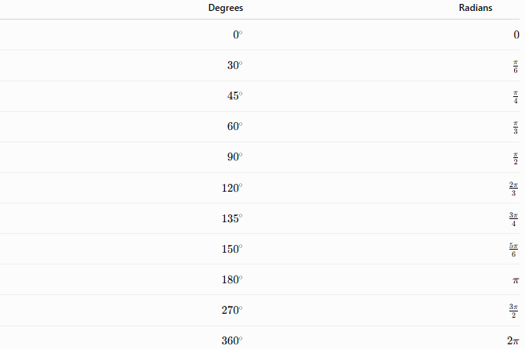
Degrees | Radians
$$0^{∘}$$ | $$0$$
$${30}^{∘}$$ | $$\frac{π}{6}$$
$${45}^{∘}$$ | $$\frac{π}{4}$$
$${60}^{∘}$$ | $$\frac{π}{3}$$
$${90}^{∘}$$ | $$\frac{π}{2}$$
$${120}^{∘}$$ | $$\frac{2π}{3}$$
$${135}^{∘}$$ | $$\frac{3π}{4}$$
$${150}^{∘}$$ | $$\frac{5π}{6}$$
$${180}^{∘}$$ | $$π$$
$${270}^{∘}$$ | $$\frac{3π}{2}$$
$${360}^{∘}$$ | $$2π$$

Examples
# Source: AI Source: Provided by: [Data Path: Persons Table -> ID Column: 1, Name_En Column: Motasem Essam] -> From: [ChatGPT] on [7/25/2026]
Example 1
Convert:
$${60}^{∘}$$
to radians.
$$60×\frac{π}{180}=\frac{π}{3}$$
Answer:
$$\boxed{\frac{π}{3}\text{ radians}}$$

Example 2
Convert:
$$\frac{π}{2}$$
to degrees.
$$\frac{π}{2}×\frac{180}{π}={90}^{∘}$$

Example 3
Find the angle when:
- Radius:
$$r=8$$
- Arc length:
$$s=12$$
Using:
$$θ=\frac{s}{r}$$
$$θ=\frac{12}{8}=1.5$$
Answer:
$$\boxed{1.5\text{ radians}}$$

Radians and the Unit Circle
# Source: AI Source: Provided by: [Data Path: Persons Table -> ID Column: 1, Name_En Column: Motasem Essam] -> From: [ChatGPT] on [7/25/2026]
On the unit circle:
- Radius:
$$r=1$$
Since:
$$θ=\frac{s}{r}$$
the angle in radians is numerically equal to the arc length.
This makes radians especially useful in higher mathematics.

Advantages of Using Radians
# Source: AI Source: Provided by: [Data Path: Persons Table -> ID Column: 1, Name_En Column: Motasem Essam] -> From: [ChatGPT] on [7/25/2026]
Radians:
- Are based directly on circle geometry.
- Simplify calculus formulas.
- Simplify derivatives and integrals of trigonometric functions.
- Are the standard unit in advanced mathematics and physics.
- Avoid unnecessary conversion factors in many equations.

Applications
# Source: AI Source: Provided by: [Data Path: Persons Table -> ID Column: 1, Name_En Column: Motasem Essam] -> From: [ChatGPT] on [7/25/2026]
Radians are used extensively in:
- Trigonometry
- Calculus
- Differential Equations
- Physics
- Engineering
- Robotics
- Computer Graphics
- Astronomy
- Navigation
- Signal Processing

Comparison with Degrees
# Source: AI Source: Provided by: [Data Path: Persons Table -> ID Column: 1, Name_En Column: Motasem Essam] -> From: [ChatGPT] on [7/25/2026]
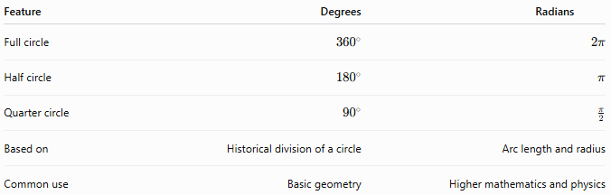
Feature | Degrees | Radians
Full circle | $${360}^{∘}$$ | $$2π$$
Half circle | $${180}^{∘}$$ | $$π$$
Quarter circle | $${90}^{∘}$$ | $$\frac{π}{2}$$
Based on | Historical division of a circle | Arc length and radius
Common use | Basic geometry | Higher mathematics and physics

Key Points
# Source: AI Source: Provided by: [Data Path: Persons Table -> ID Column: 1, Name_En Column: Motasem Essam] -> From: [ChatGPT] on [7/25/2026]
- A Radian is defined by:
$$θ=\frac{s}{r}$$
- One complete revolution is:
$$2π\text{ radians}$$
- Relationships:
$${180}^{∘}=π\text{ radians}$$
$${360}^{∘}=2π\text{ radians}$$
- Conversion:
Degrees to radians:
$$θ_{\text{rad}}=θ_{\text{deg}}×\frac{π}{180}$$
Radians to degrees:
$$θ_{\text{deg}}=θ_{\text{rad}}×\frac{180}{π}$$

Conclusion
# Source: AI Source: Provided by: [Data Path: Persons Table -> ID Column: 1, Name_En Column: Motasem Essam] -> From: [ChatGPT] on [7/25/2026]
A Radian is the natural mathematical unit for measuring angles, defined by the ratio of an arc's length to the radius of a circle. Because it is directly connected to the geometry of circles, the radian simplifies many mathematical and physical formulas. It is the preferred unit in trigonometry, calculus, differential equations, physics, engineering, robotics, computer graphics, astronomy, navigation, and signal processing, where precise relationships involving circular motion and periodic phenomena are essential.

